Given following data sets, create a list detail view show in Image below.

Use any JavaScript framework of your choice.

Main goal of the page would be to show details on right side panel upon selecting a row from the list on left side.

Changes on the right side panel should be reflected in grid.

Spotlight search at top, will filter rows in grid, a substring in either Access Level Name, Reader Type, or Reader Name is a match.

**UI Mockup**

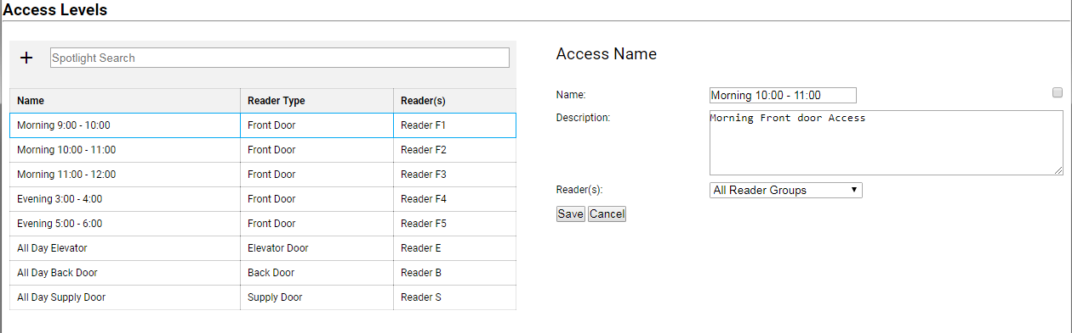

**Datasets**

accessLevels json

===========================

[{

"id": 1,

"name": "Morning 9:00 - 10:00",

"readerId": 10,

"Description": "Morning Front door Access"

},

{

"id": 2,

"name": "Morning 10:00 - 11:00",

"readerId": 11,

"Description": ""

},

{

"id": 3,

"name": "Morning 11:00 - 12:00",

"readerId": 12,

"Description": ""

},

{

"id": 4,

"name": "Evening 3:00 - 4:00",

"readerId": 13,

"Description": ""

},

{

"id": 5,

"name": "Evening5:00 - 6:00",

"readerId": 14,

"Description": ""

},

{

"id": 6,

"name": "All Day Elevator",

"readerId": 15,

"Description": ""

},

{

"id": 7,

"name": "All Day Back Door",

"readerId": 16,

"Description": ""

},

{

"id": 8,

"name": "All Day Supply Door",

"readerId": 17,

"Description": ""

}

]

===========================

"readers"

===========================

[{

"id": 10,

"typeId": 1,

"name": "Reader F1"

},

{

"id": 11,

"typeId": 1,

"name": "Reader F2"

},

{

"id": 12,

"typeId": 1,

"name": "Reader F3"

},

{

"id": 13,

"typeId": 1,

"name": "Reader F4"

},

{

"id": 14,

"typeId": 1,

"name": "Reader F5"

},

{

"id": 15,

"typeId": 2,

"name": "Reader E"

},

{

"id": 16,

"typeId": 3,

"name": "Reader B"

},

{

"id": 17,

"typeId": 4,

"name": "Reader S"

}

],

===========================

"readerTypes"

===========================

[{

"id": 1,

"name": "Front Door"

},

{

"id": 2,

"name": "Elevator Door"

},

{

"id": 3,

"name": "Back Door"

},

{

"id": 4,

"name": "Supply Door"

}

]

===========================